**ASSIGNMENT-1**

**WEB PAGE CREATION**

|  |  |
| --- | --- |
| NAME: | ARYAN GUPTA |
| SAP ID: | 500094848 |
| COURSE: | BBA (ABD) |
| SEMESTER: | 4TH |

**CODE:**

**INPUT:**

<html>

<head>

<Title> UBS </TITLE>

<body style="background-color:GREY;">

<style>

img {

float: right;

}

    </style>

<h1><b>USB</b></h1>

<img src="C:/Users/hp/Downloads/LOGO.JPG" alt="University Logo" width="200">

<marquee direction="left" scrollamount="20">WELCOME TO UBS.</marquee>

<br>

<video src= "C:/Users/hp/Downloads/UPES VI.mp4" controls>

</video>

<audio controls>

<source src="C:/Users/hp/Downloads/ALAN.mp3" type="audio/mpeg">

</audio>

<p>UBS is the school of business which let you gain skills in your interest domain of business with all the specialization.UPES ranked number 1 private university in terms of academic reputation and 9 in the list of top 10 institutions in India, by the QS Asia University Rankings 2023. UPES received the 'Institution of Happiness' award by QS I-Gauge in association with ASSOCHAM at the Academic Excellence Conclave.</p>

<ol>

<li>Admission Requirements</li>

<li>Programs Offered</li>

<li>Faculty and Staff</li>

<li>Campus Life</li>

</ol>

<ul>

<li>News and Events</li>

<li>Alumni</li>

<li>Research</li>

<li>Community Engagement</li>

</ul>

<marquee direction="left" scrollamount="5">The New sesson will start from 15th Aug 2023.</marquee>

<table border="3">

<tr>

<th>Name</th>

<th>Position</th>

<th>Email</th>

</tr>

<tr>

<td>Aryan Gupta</td>

<td>Professor</td>

<td>Aryan@university.edu</td>

</tr>

<tr>

<td>Parth Gupta</td>

<td>Assistant Professor</td>

<td>Parth@university.edu</td>

</tr>

</table>

<p><b>Important Reminder:</b> All are requested to be in proper uniform</p>

<p><i>This Program is to make student understand the real world Business.</i></p>

<p style="background-color:Powder blue;">Please be on time in the class.</p>

<p>Visit our <a href="https://www.upes.ac.in">website</a> for more information.</p>

</HEAD>

</HTML>

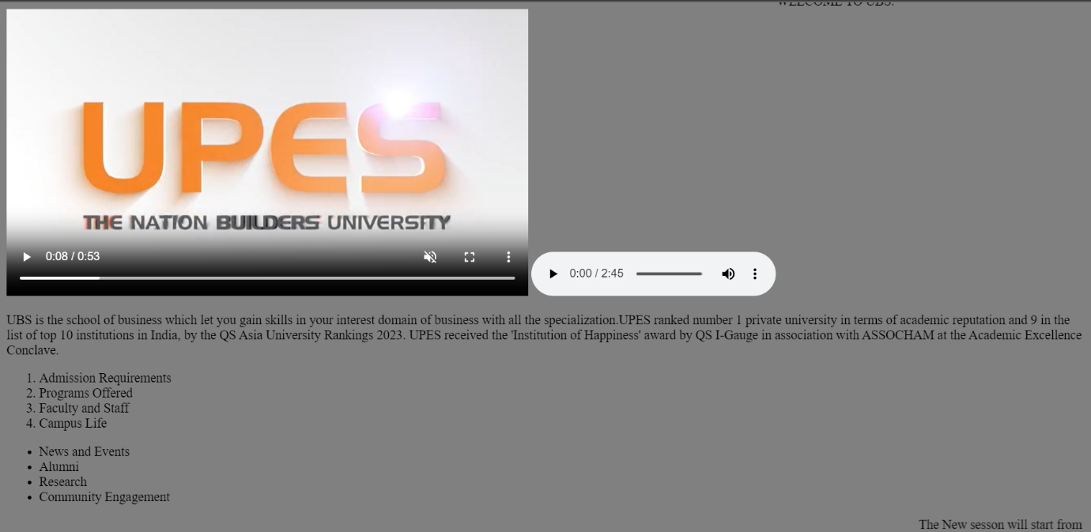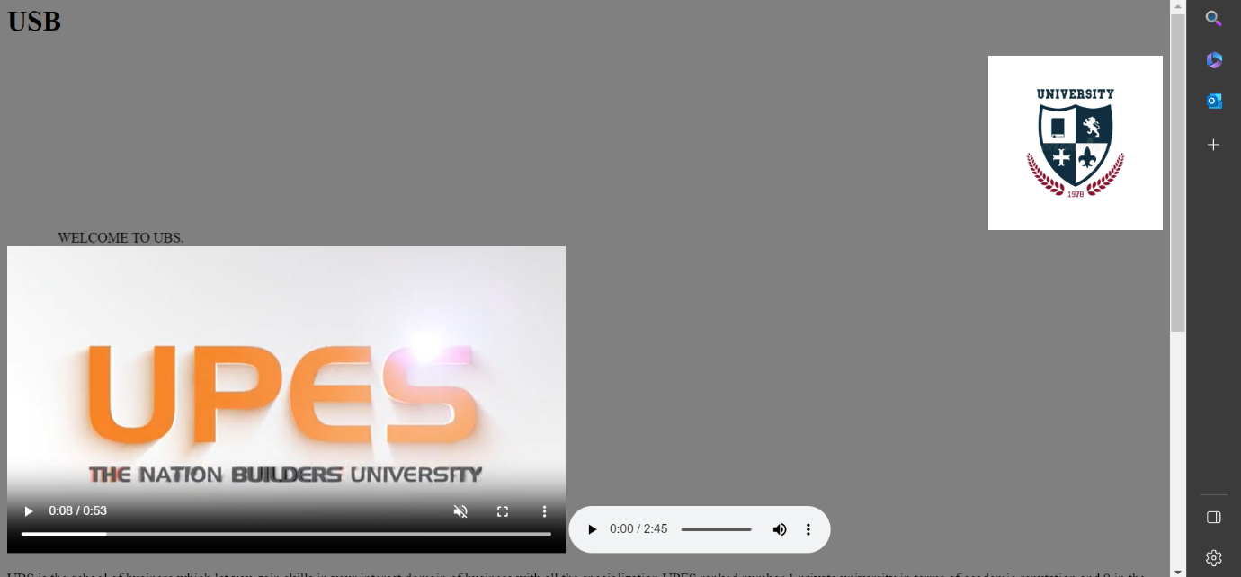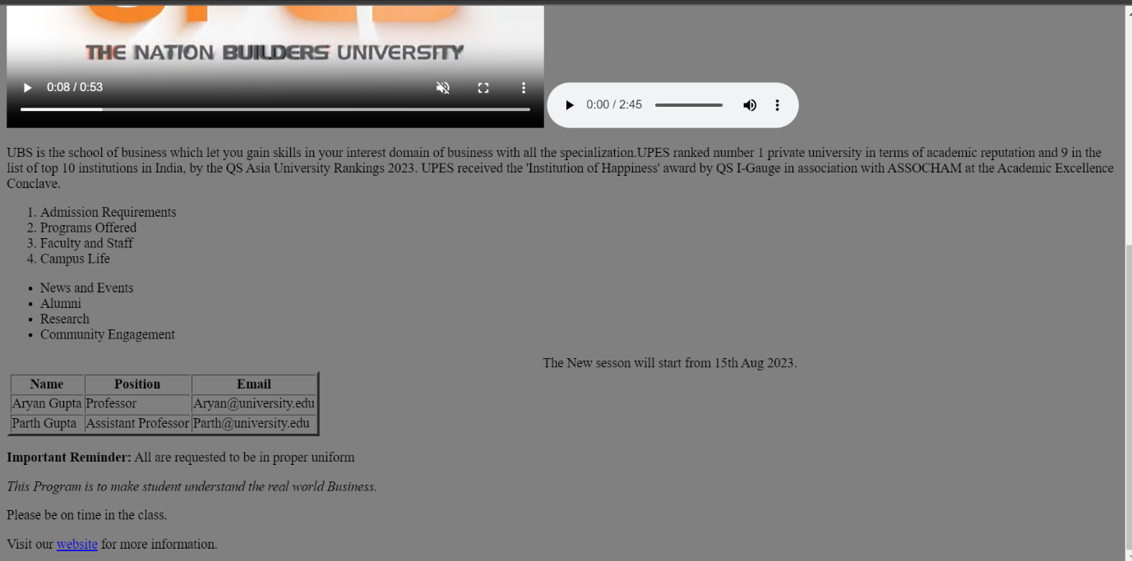

**CODE: BMW WEB SITE**

**INPUT :**

<html>

<head>

<title> BMW </TITLE>

<body background="color:Grey">

<header>

<h1> BMW </h1>

<nav>

<ul>

<li><a href="https://www.bmw.in/en/index.html">Home</a></li>

<li><a href="https://www.bmw.in/en/all-models.html">Model</a></li>

<li><a href="https://www.bmw.in/en/topics/owners/original-bmw-accessories/bmw-accessories-overview.html">Accessories</a></li>

</ul>

</nav>

</header>

<main>

<section id="intro">

<h2>Welcome to BMW</h2>

<p>Discover the ultimate driving machine. Explore our range of luxury cars and find the perfect BMW for you.</p>

</section>

<table border="3" cellpadding="2">

<tr>

<th>MODEL NAME</th>

<th>PRICE</th>

<th>PHOTO</th>

</Tr>

<tr>

<td><b>X1</td>

<td><b><background-color: white;>₹ 47.90 Lakh</td>

<td><img src = "C:\Users\hp\Downloads\X1.png"></td>

</tr>

<tr>

<td><b>M3</td>

<td><b><background-color: white;>₹ 70 Lakh</td>

<td><img src = "C:\Users\hp\Downloads\M3.png" width="300"

height="250"></td>

</tr>

<tr>

<td><b>M3 CS</td>

<td><b><background-color: white;>₹ 74 Lakh</td>

<td><img src = "C:\Users\hp\Downloads\en-2-bmw-m3-cs-flyout.png.asset.1674829740232.png" width="300"

height="250"></td>

</tr>

<tr>

<td><b>M3 COMPETITION</td>

<td><b><background-color: white;>₹ 84 Lakh</td>

<td><img src = "C:\Users\hp\Downloads\EN-bmw-m3-touring-flyout.png.asset.1669205606195.png" width="300"

height="250"></td>

</tr>

<tr>

<td><b>M4 COMPETITION</td>

<td><b><background-color: white;>₹ 77 Lakh</td>

<td><img src = "C:\Users\hp\Downloads\M4.png" width="300"

height="250"></td>

</tr>

<tr>

<td><b>M3 CS</td>

<td><b><background-color: white;>₹ 74 Lakh</td>

<td><img src = "C:\Users\hp\Downloads\en-2-bmw-m3-cs-flyout.png.asset.1674829740232.png" width="300"

height="250"></td>

</tr>

</body>

<audio controls autoplay loop>

<source src="C:\Users\hp\Downloads/ALAN.mp3" type="audio/mpeg">

</audio>

</HEAD>

<html>

**OUTPUT:**

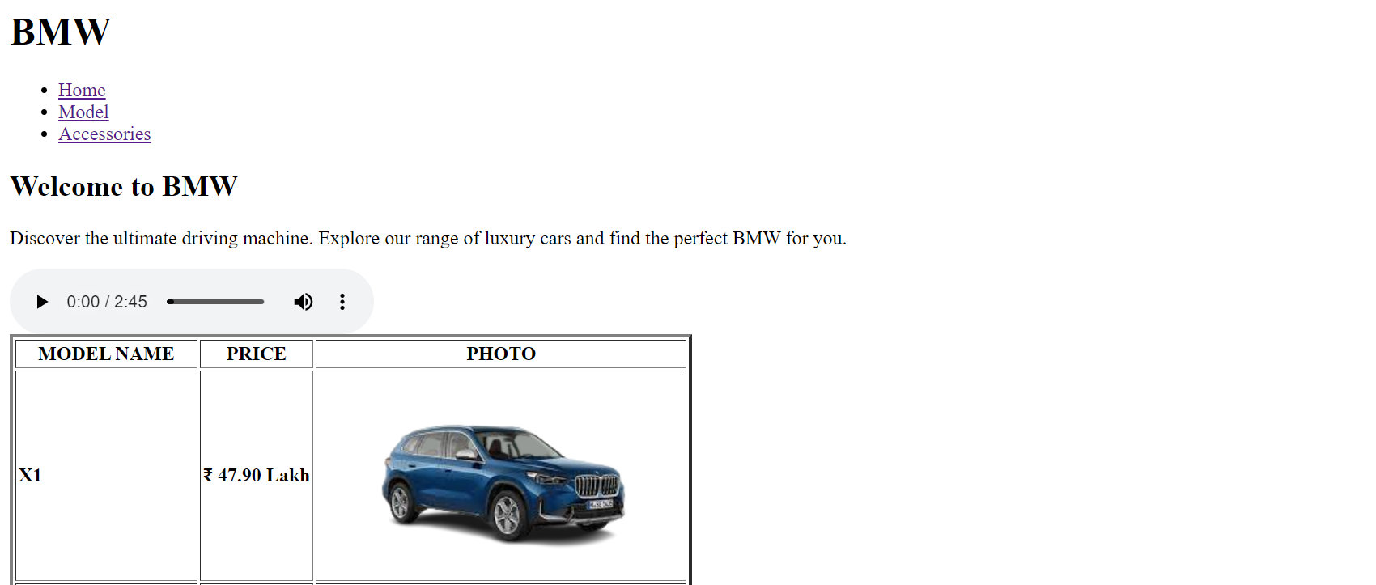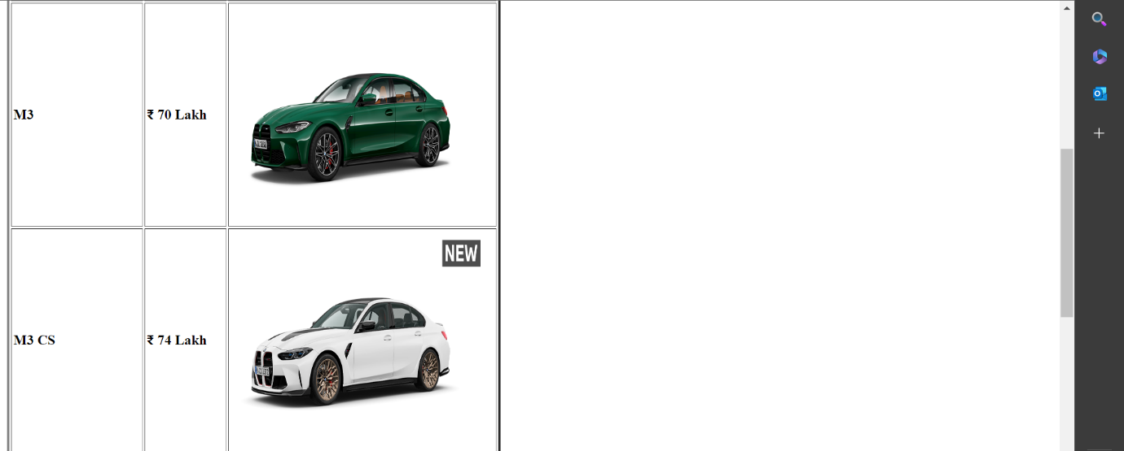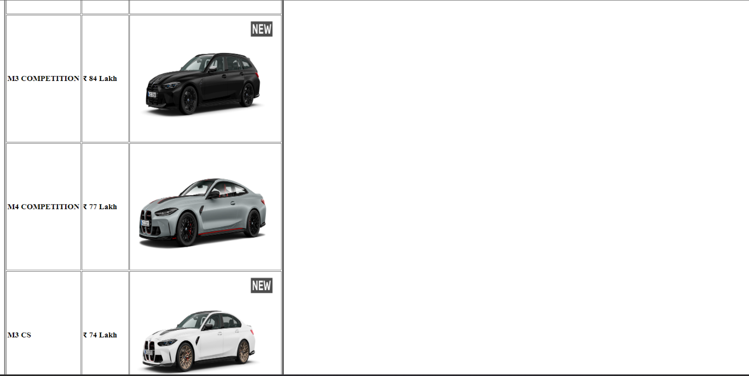

**EXTERNAL CSS:**

**<html>**

**<head>**

**<link rel="stylesheet" href="style.css">**

**</head>**

**<body>**

**<h1>this is a heading</h1>**

**<p> this is a paragraph.</p>**

**</body>**

**</html>**

**STYLE CSS:**

**body {**

**background-color: grey;**

**}**

**h1 {**

**color:Black;**

**}**

**p{ color: white;**

**}**

**INTERNAL CSS:**

**<html>**

**<head>**

**<style>**

**body {background-color:skyblue;}**

**h1 {color:blue;}**

**p {color:red;}**

**</style>**

**</head>**

**<body>**

**<h1>this is a heading</h1>**

**<p>this is a paragraph.</p>**

**</body>**

**</html>**